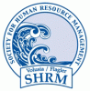 | Volusia / Flagler SHRM  April 2013  PROGRAM INFO
This program has been submitted for 1.0 strategic re-certification credit!
Program Overview:  “Funding Contentment in a Chaotic World”  - Identifying the areas employees get distracted and off task during the work day.  - Identifying the importance of a Time Management System.  - Learning how to implement this system as an HR manager.  - Learning how to teach others to use this system.  Speaker Information:  Karen Nutter, Life Coach, Life Coaching by Karen, LLC  This presenter is a Certified Hyponolinguistic Practitioner, Certified Intrinsic Coach and a Certified Master Coach Trainer. Life Coaching by Karen, LLC, focuses on professionals and companies with stressed employees to help find and create a balance in both life and working atmospheres. She trains NEW HEALTH coaches in 10 states along the East Coast. Karen focuses on promoting productive lives, actions and behaviors.  http://www.youtube.com/watch?v=i0xo9UCnhr8 |  | Date:  Wednesday, April 17th, 2013  Location:  Daytona Beach Int’l Airport, 2nd Floor, Volusia Room  Time:  7:45am-9:00am
 |  | 
Thank you to our Diamond Chapter Sponsors Below:
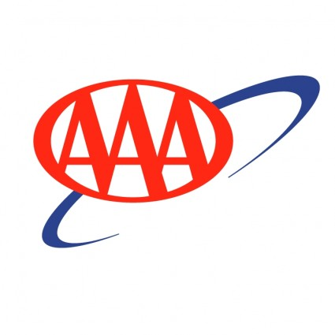

Click here for details on our chapter sponsorship program.

Send your inquiries to:
DaytonaSHRM@gmail.com


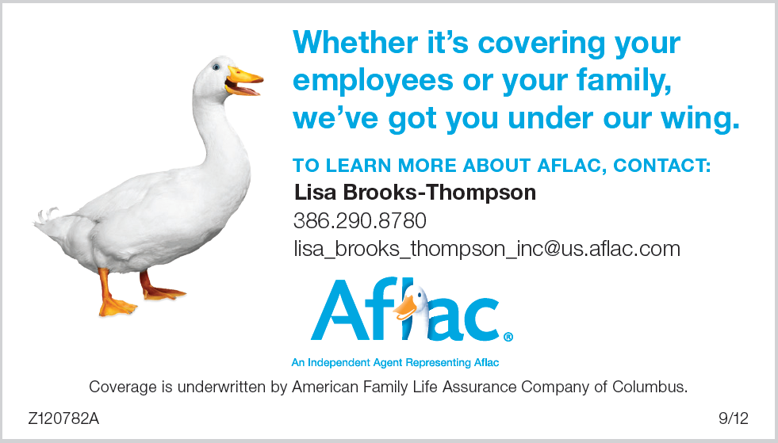
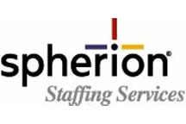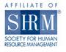

CONTACT US

E-Mail: DaytonaSHRM@gmail.com Address: P.O. Box 10366 Daytona Beach, Fl 32120
Website www.Volusiaflagler.shrm.org

